**VASAVI COLLEGE OF ENGINEERING**

**(AUTONOMOUS)**

**(Affiliated to Osmania University)**

# Hyderabad-500031

DEPARTMENT OF : Information Technology

NAME OF THE LABORATORY: Data Structures

Name: Zoha Tabassum HT No.:1602-20-737-053

**BODY MASS INDEX(BMI)**

**ABSTRACT:**

The body mass index (BMI) is the metric currently in use for defining anthropometric height/weight characteristics in adults and for categorizing them into groups. The common interpretation is that it represents an index of an individual’s fatness. The BMI also does not capture information on the mass of fat in different body sites. The latter is related not only to untoward health issues but to social issues as well. Lastly, current evidence indicates there is a wide range of BMIs over which mortality risk is modest, and this is age related.

**Requirement Analysis:**

List of Tables:

* User
* BMI
* Admin
* Final Report

List of attributes with their domain type:

USER:

* user_name varchar2(20)
* user_id number(5)
* user_gender varchar2(5)
* user_age number(5)
* user_height number(5)
* user_weight number(5)

BMI:

* admin_id number(5)
* first_name varchar2(20)
* last_name varchar2(20)
* email varchar2(50)
* password varchar2(5)
* user_name varchar2(20)

ADMIN:

* admin_id number(5)
* first_name varchar2(20)
* last_name varchar2(20)
* email varchar2(50)
* password varchar2(5)
* user_name varchar2(20)

FINALREPORT:

* create table Finalreport(
* user_id number(5),
* user_name varchar2(20),
* user_height number(5),
* user_weight number(5),
* msg varchar2(50));

**DESIGN**

ENTITY RELATIONSHIP DIAGRAM

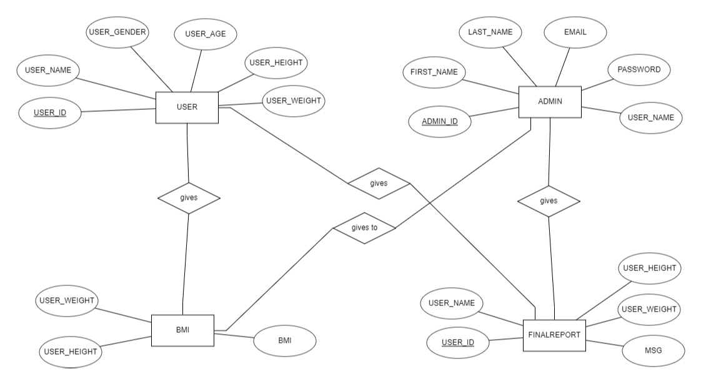

**DDL OPERATIONS:**

1.

CREATE TABLE Users(

user_name varchar2(20),

user_id number(5),

user_gender varchar2(5),

user_age number(5),

user_height number(5),

user_weight number(5));

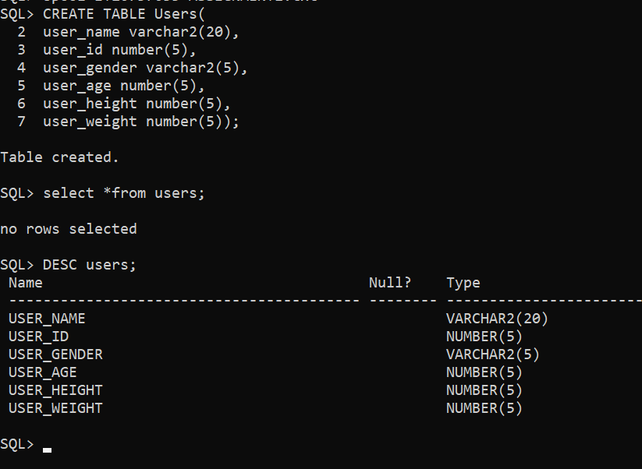

SETTING USER_ID AS PRIMARY KEY:

alter table users add primary key(user_id);

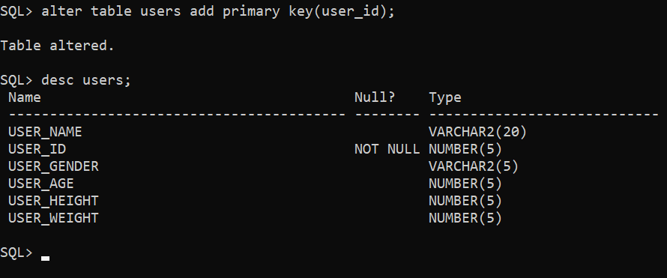

2.

create table BMI(

user_height number(5),

user_weight number(5),

bmi number(5));

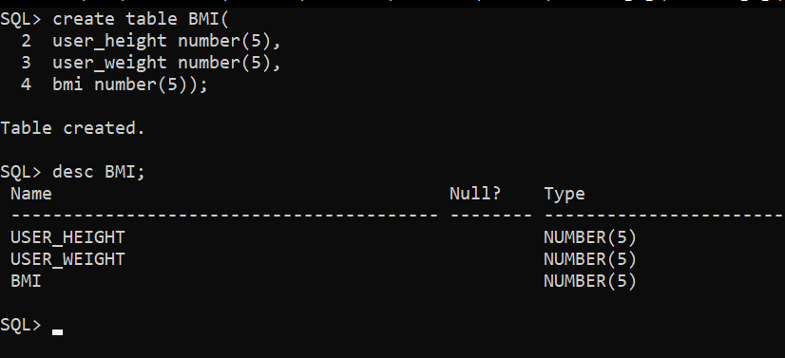

3.

create table Admin(

admin_id number(5),

first_name varchar2(20),

last_name varchar2(20),

email varchar2(50),

password varchar2(5),

user_name varchar2(20));

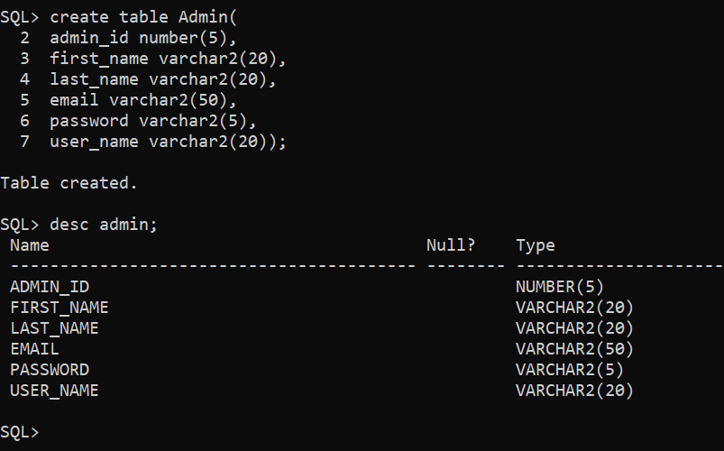

**SETTING ADMIN_ID AS PRIMARY KEY:**

alter table Admin add primary key(admin_id);

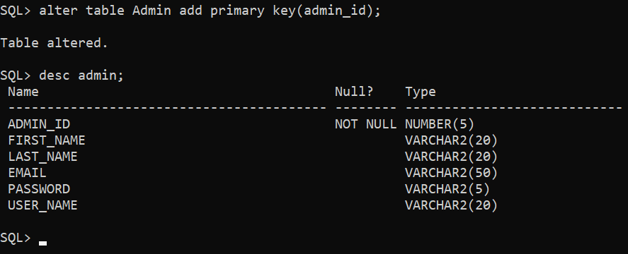

4.

create table Finalreport(

user_id number(5),

user_name varchar2(20),

user_height number(5),

user_weight number(5),

msg varchar2(50));

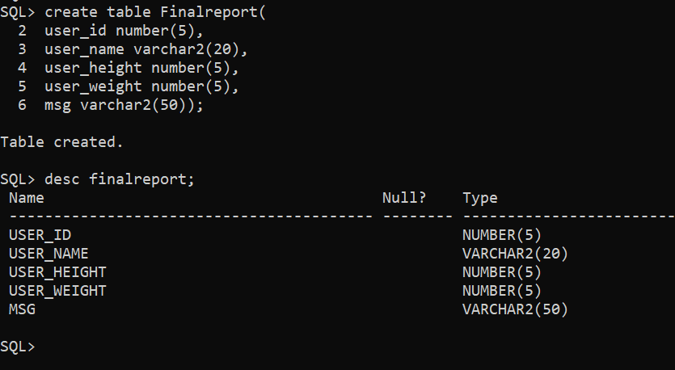

Making user_id as foreign key:

Alter table finalreport add foreign key(user_id) references users;

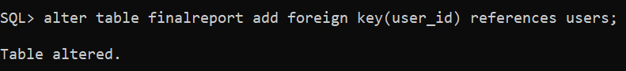

**DML OPERATIONS:**

**1.Inserting values into users table:**

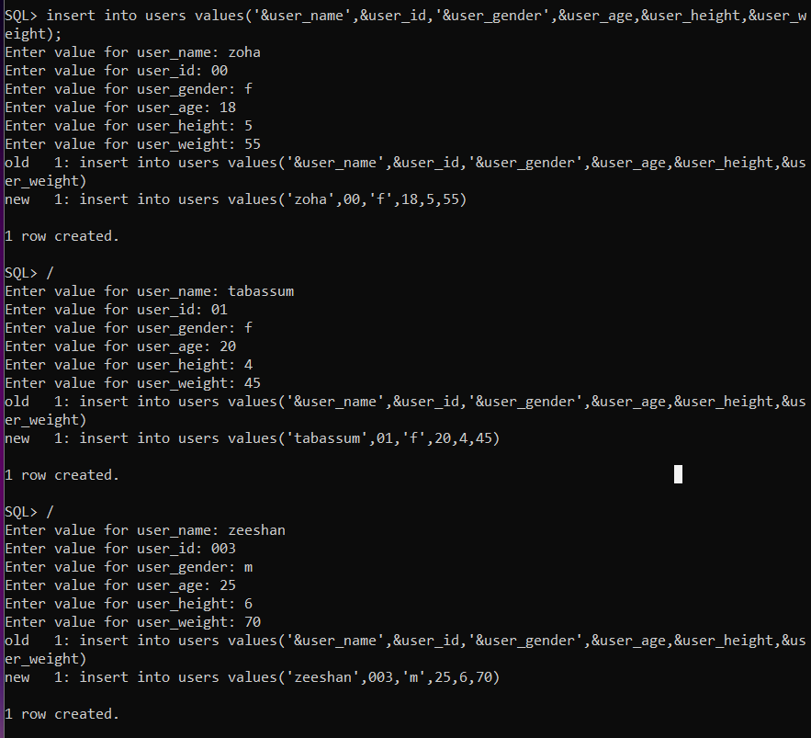

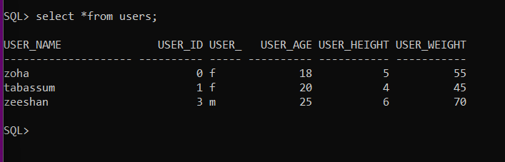

**2.Inserting values into bmi table:**

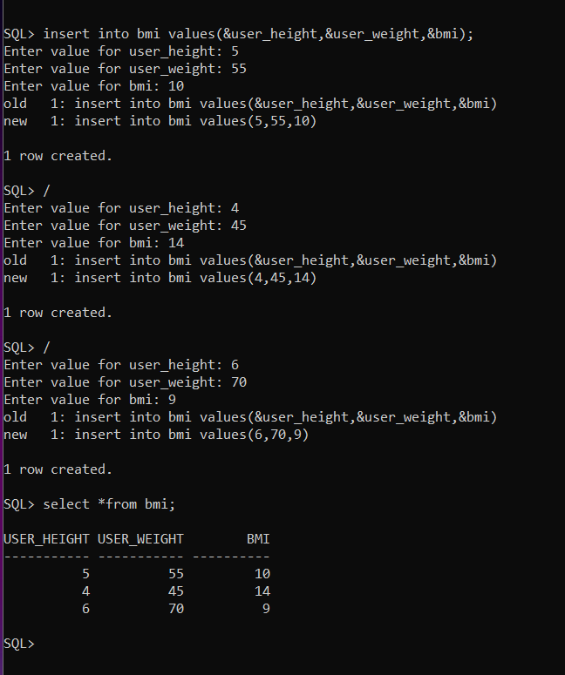

**3.Inserting values into admin table:**

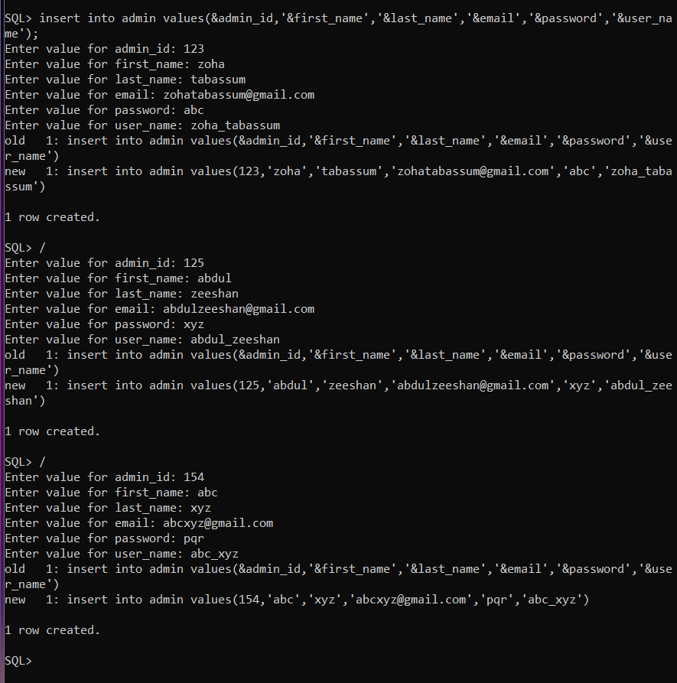

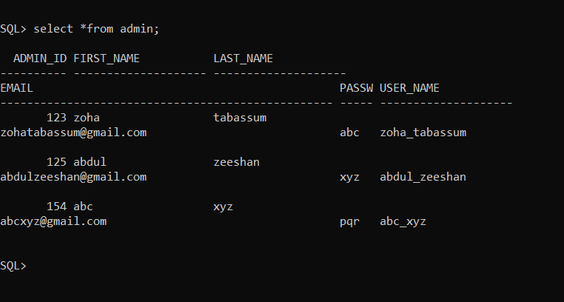

**4.Inserting values into Finalreport table:**

